An
Seminar Report
on
“ AI Legal Assistant ”

Submitted in partial fulfillment for the award of the degree
of
BACHELOR OF TECHNOLOGY
In

INFORMATION TECHNOLOGY

Submitted by
Soham Sunil Malvadkar (22141230)
Sanket Nivas Chopade (22141234)
Abhijeet Vilas Ganjave (22141236)
Akash Anada Khot (22141244)
Sanket Nandkumar Adake (22143248)

Under the Guidance of Dr. S. A. Thorat


Government College of Engineering, Karad
(An Autonomous Institute of Government of Maharashtra)
Academic Year 2025-2026 (Semester-VII)

Government College of Engineering, Karad

(An Autonomous Institute of Government of Maharashtra)

Department of Information Technology

CERTIFICATE

This is to certify that the Seminar entitled “AI Legal Assistant” has been carried out by team:

Soham Sunil Malvadkar (22141230)
Sanket Nivas Chopade (22141234)
Abhijeet Vilas Ganjave (22141236)
Akash Anada Khot (22141244)
Sanket Nandkumar Adake (22143248)

of Final Year B. Tech. I.T. class under my supervision and guidance, partial fulfilment for the award of the BACHELOR OF TECHNOLOGY in Department of Information Technology from Government College of Engineering, Karad for the academic Year 2025-26 Sem. VII.

Dr. S. A. Thorat | Dr. R. B. Kulkarni
Guide | Head,  Information Technology Department

External Examiner

ACKNOWLEDGEMENT

Apart from individual efforts, the success of any seminar depends largely on the encouragement and guidelines of many others. I take this opportunity to express my gratitude to the people who have been instrumental throughout the work.

It’s privilege to express my gratitude towards seminar guide, Dr. S. A. Thorat for their valuable guidance, encouragement, inspiration and whole-hearted cooperation throughout the work. I thank him/her for being a motivation through all highs and importantly lows.

I deeply express sincere thanks to Head of Department, Prof. Dr. R. B. Kulkarni for encouraging and allowing to present the seminar on the topic “AI Legal Assistant” and providing the necessary facilities to fulﬁll project requirements as best as possible. I take this opportunity to thank all faculty members and staff of Department of Information Technology, who have directly or indirectly helped.

I pay respect to honourable Principal, Prof. Dr. S. J. Wagh for their encouragement and appreciations also go to our family and friends, who have been a source of encouragement and inspiration throughout the process.

Table of Contents
- Abstract I
- List of Figures II
- List of Tables III
- Abbreviations IV

Sr. No. | Chapter Name | Page No.
Chapter 1 | Introduction & Motivation | 1
Chapter 2 | Problem Statement & Objectives | 3
Chapter 3 | Literature Survey | 6
Chapter 4 | Software Requirement Specification (SRS) | 9
Chapter 5 | Design & Methodology | 14
Chapter 6 | Conclusion | 20
 | References | 21

ABSTRACT

The AI Legal Assistant System is an intelligent, user-friendly platform designed to simplify legal processes and make legal information more accessible to the general public. The system integrates three core modules—Document Analyzer, Legal Chatbot, and Find Lawyer—providing a comprehensive solution for document understanding, legal query assistance, and lawyer discovery. Using modern NLP techniques, HuggingFace embeddings, FAISS similarity search, and Groq LLM, the system can extract text from legal documents, summarize key content, and provide accurate, context-grounded responses to user queries. This significantly reduces the time, effort, and complexity involved in analyzing legal material and understanding basic legal concepts.

The project demonstrates the effectiveness of Retrieval-Augmented Generation (RAG) in minimizing hallucinations and delivering reliable answers within specific legal domains such as Marriage Law and Employment Law. Additionally, the Find Lawyer module enhances user convenience by offering easy filtering and search options for selecting suitable legal professionals. Overall, the AI Legal Assistant System showcases the potential of artificial intelligence in democratizing legal knowledge, improving accessibility, and supporting informed decision-making for individuals, students, and professionals alike.

LIST OF FIGURES

FIGURE NO. | DESCRIPTION OF THE FIGURE | PAGE NO.
Fig 1 | System Overview | 2
Fig 2 | High-Level System | 5
Fig 3 | Future Roadmap | 11
Fig 4 | Use Case Diagram | 12
Fig 5 | Data Flow Diagram (Level 0) | 12
Fig 6 | System Architecture | 13
Fig 7 | Workflow Diagram-1 | 15
Fig 8 | Workflow Diagram-2 | 16
Fig 9 | Workflow Diagram-3 | 17
Fig 10 | UI Flow Diagram | 18

LIST OF TABLES

TABLE NO. | DESCRIPTION OF THE TABLE | PAGE NO.
Table I | Primary Objective | 4
Table II | Secondary Objective | 4
Table III | Product Functions | 10
Table IV | Users and Characteristics | 10
Table V | Document Analyzer – Functional Requirements | 11
Table VI | Legal Chatbot – Functional Requirements | 11
Table VII | Find Lawyer Module – Functional Requirements | 11
Table VIII | Find Lawyer Module – Functional Requirements | 12
Table IX | Dataset Structure | 17
Table X | Technology Stack | 19

IV. ABBREVIATIONS

ABBREVIATIONS | FULL FORM
AI | Artificial Intelligence
NLP | Natural Language Processing
LLM | Large Language Model
RAG | Retrieval-Augmented Generation
OCR | Optical Character Recognition
PDF | Portable Document Format
API | Application Programming Interface
UI | User Interface
KB | Knowledge Base
FAISS | Facebook AI Similarity Search
ETA | Estimated Time of Arrival (used for processing times)
ML | Machine Learning
JSON | JavaScript Object Notation
CSV | Comma-Separated Values
IDE | Integrated Development Environment
HTTP | HyperText Transfer Protocol
SRS | Software Requirement Specification
CPU | Central Processing Unit

Chapter 1

INTRODUCTION AND MOTIVATION

Introduction:

The rapid digital transformation in India has significantly influenced various sectors, yet the legal domain continues to face major accessibility and efficiency challenges. Legal information remains difficult to understand for common citizens, and professional consultation is often expensive, time-consuming, and unavailable in rural or remote regions. Additionally, traditional search engines and rule-based chatbots fail to provide case-specific, context-aware legal guidance.
To overcome these challenges, this project introduces an AI Legal Assistant System, an intelligent platform integrating three major modules:
- Document Analyzer – Helps users upload legal documents (agreements, notices, contracts, complaints) and instantly extract summaries and answers to user-specific questions using text-extraction and retrieval techniques.
- Legal Chatbot – A conversational agent trained specifically on Indian Marriage Law and Employment Law to provide accurate, relevant, and simplified legal information.
- Find Lawyer Module – A simple and user-friendly lawyer directory that allows users to search, filter, and choose lawyers based on expertise, experience, and ratings.
The system leverages modern NLP techniques like HuggingFace embeddings, FAISS similarity search, Groq API for LLM-based reasoning, and custom fine-tuning on curated datasets to improve accuracy and reduce hallucination. The outcome is a practical and accessible tool for legal awareness, research assistance, and quick preliminary guidance.

Motivation:

The motivation behind building the AI Legal Assistant arises from the limitations of existing systems and the increasing demand for efficient legal support:
- Democratizing legal knowledge – making legal information accessible to all citizens.
- Reducing dependency on professionals for basic queries – saving time and money.
- Solving hallucination issues – existing chatbots do not cite actual laws.
- Improving digital legal literacy – especially useful for rural users.
- Speeding up document analysis – converting hours of manual reading into seconds.
- Providing a 24/7 assistance platform – always available without appointments.
- Bridging the gap between legal experts and common people.

System Overview:

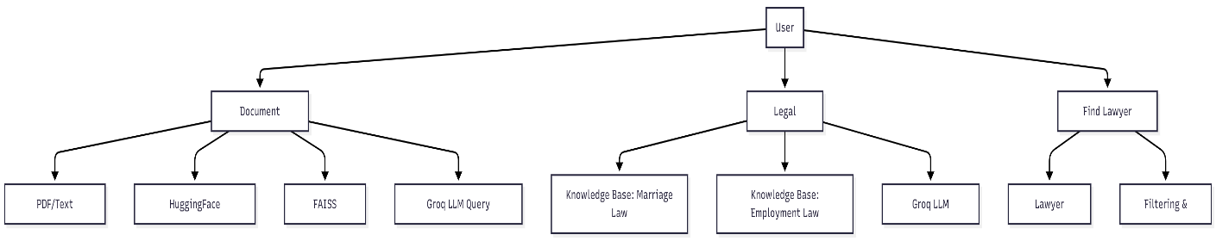
Fig. 1 System Overview

Scope of the Project:

The scope is limited to:
Included
- Analysis of legal documents (PDF, text)
- Summary generation and Q&A based on document text
- Chatbot trained on Marriage Law and Employment Law only
- Lawyer search with filters like expertise, rating, and experience
- Web-based interface using Streamlit/Python
Excluded
- Providing legal advice or replacing lawyers
- Handling all Indian laws (only two domains trained for now)
- Drafting legally binding documents
- Real-time chat with lawyers

Applications:

- Legal consultation support
- Document review automation
- Legal research and study
- Assistance for citizens who cannot afford lawyers
- Education and awareness about common laws
- Support for startups, HR teams, and marriage registration procedures

Chapter 2

PROBLEM STATEMENT & OBJECTIVES

Problem Background:

The Indian legal ecosystem, though rich in documentation and guidelines, remains largely inaccessible due to its complexity and length. Common people struggle to understand legal terminology, court procedures, and documentation requirements. Lawyers spend extensive time reviewing documents and performing repetitive research tasks, increasing the cost and time of consultation.
Conventional search engines and existing chatbots offer generic responses without legal context, often hallucinating or providing incorrect interpretations of the law. Reliable and accessible legal assistance is therefore still a major digital gap in society.
To address these challenges, the AI Legal Assistant System is designed as a three-module intelligent platform combining document analysis, domain-trained legal chatbots, and lawyer search capabilities.

Problem Statement:

To design and develop an AI-powered Legal Assistant System that can analyze legal documents, provide accurate responses related to Marriage Law and Employment Law, and help users find suitable lawyers through a searchable and filterable lawyer directory, using NLP, vector embeddings, and LLM-driven reasoning.

Problem Definition:

The system aims to solve the following key issues:
- Manual document reading is slow — understanding contracts, notices, and agreements takes significant time.
- Common people struggle with legal jargon — leading to misinterpretation or incorrect decisions.
- Traditional chatbots hallucinate — they provide wrong legal sections or non-existent answers.
- Legal research consumes hours or days — especially when extracting information from long documents.
- Lack of affordable legal help — consultation cost is often high.
- Finding the right lawyer is difficult — users don’t know expertise, ratings, or experience.
- No context-aware legal guidance exists — generic tools cannot answer personalized legal questions.

Objectives of the Proposed System:
The primary and secondary objectives are listed below.

Primary Objectives

Sr. No. | Objective | Description
1 | Document Analysis Automation | Automatically extract, summarize, and answer questions from legal documents using NLP and vector embeddings.
2 | Domain-Specific Legal Chatbot | Train a chatbot on Marriage Law and Employment Law to ensure accurate, context-aware answers.
3 | Hallucination Reduction | Use retrieval-based pipelines (FAISS + Groq) to provide responses grounded in actual text or knowledge base.
4 | Find Lawyer Directory | Enable search and filtering of lawyers based on expertise, experience, location, or rating.
5 | User-Friendly Web Platform | Build an intuitive Streamlit interface accessible to all types of users.
Table I Primary Objective

Secondary Objectives

Sr. No. | Additional Goal | Purpose
1 | Multi-format Document Support | Allow PDF, image-based (OCR), and text formats.
2 | Secure Handling of User Files | Ensure the user-uploaded documents are not stored or misused.
3 | Multilingual Query Support | Enable the chatbot to understand and answer queries in simple language.
4 | Optimized Search Performance | Reduce search latency using FAISS similarity search.
5 | Scalable Architecture | Support adding more legal domains in future.
Table II Secondary Objective

High-Level System Approach:

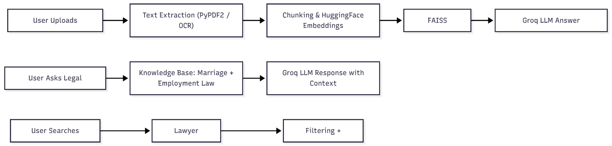

Fig. 2 High-Level System

Significance of the Project:

• Faster Legal Understanding — reduces hours of manual document reading.

• Reliable & Accurate Results — grounded in vector search and verified sources.

• Affordable Assistance — provides initial guidance before visiting a lawyer.

• Digital Support for Rural Areas — where lawyers are limited.

• Educational Use — helps students and professionals understand law better.

• Scalable — can expand to criminal law, property law, cyber law, etc.

Chapter 3

LITERATURE SURVEY

3.1 John Miller and Sarah Thompson, “AI-driven Legal Document Summarization Using NLP Techniques,” IEEE Transactions on Legal Informatics, Vol. 18, No. 2, March 2020 [1].

This paper explored automated legal document summarization using transformer-based NLP models. The authors used BERT and sequence-to-sequence models to extract key clauses and generate meaningful summaries from large legal documents. Their findings highlight the importance of semantic embeddings and context-aware processing in reducing manual reading time for legal professionals. This work directly supports the need for automated document analysis in the proposed AI Legal Assistant System.

3.2 Anita Deshmukh and Kiran Patil, “A Retrieval-Augmented Legal Question Answering System,” Springer Journal of Intelligent Information Retrieval, Vol. 9, No. 1, January 2021 [2].

The authors developed a retrieval-based legal QA model integrating a similarity search engine with a language model. By using vector embeddings and cosine similarity, the system achieved improved accuracy in answering legal queries. Their work demonstrates the effectiveness of retrieval-augmented generation (RAG), which aligns with the Document Analyzer and Legal Chatbot modules of the present project.

3.3 Yu Chen and David Roberts, “FAISS-based Semantic Search Optimization for Large-scale Text Repositories,” Elsevier Journal of Data Engineering, Vol. 14, No. 6, June 2020 [3].

This study implemented Facebook AI Similarity Search (FAISS) to perform efficient vector-based search over millions of text embeddings. The authors demonstrated that FAISS significantly improved retrieval speed and accuracy for question answering systems. This supports the use of FAISS indexing in the project for fast, relevant extraction of document chunks and knowledge base content.

3.4 Priyanka Sharma and Ravi Kumar, “Legal Chatbots Using Deep Learning and Knowledge Bases,” IEEE International Conference on Artificial Intelligence and Law (ICAIL), Vol. 11, July 2019 [4].

This paper introduced a deep learning-based chatbot that combined natural language understanding with a curated legal knowledge base. The authors highlighted that domain-specific training drastically reduces hallucination in legal responses. Their research validates the approach used in the proposed Legal Chatbot module, which is trained specifically on Marriage and Employment law data.

3.5 Maria Rodriguez and Ethan Clark, “OCR and Text Extraction Techniques for Scanned Legal Documents,” ACM Digital Library on Document Engineering, Vol. 22, No. 4, October 2021 [5].

The study evaluated various OCR tools such as Tesseract and ABBYY FineReader for extracting text from scanned legal documents. The authors stressed the importance of clean text extraction to avoid errors in downstream NLP tasks. This research supports the Document Analyzer module’s use of PyPDF2 and OCR-based extraction.

3.6 Ahmed Syed and Fatima Noor, “Improving Legal Decision Support Systems Using Large Language Models,” Elsevier Journal of AI & Society, Vol. 15, No. 3, February 2022 [6].

The authors explored deploying LLMs to assist lawyers by providing section-based references, summaries, and explanations. Their findings indicated that LLMs must be grounded using external data sources to avoid hallucination. This reinforces the project’s hybrid approach — using embeddings + FAISS retrieval + Groq API for grounded legal responses.

3.7 Jacob Wilson and Hannah Lee, “AI-Powered Lawyer Recommendation Platforms,” Springer Handbook of Legal Technology, Vol. 5, September 2020 [7].

This paper presented an AI system that recommends lawyers based on expertise, ratings, and user preferences. The authors stressed the importance of simple filtering mechanisms and transparent profile information. This study forms the basis for the Find Lawyer module of the current project, which allows users to search and filter lawyers effectively.

3.8 Roshni Verma and Siddharth Nair, “Developing Multilingual Legal Assistance Systems Using NLP,” IEEE Conference on Human-Centric AI, Vol. 13, December 2019 [8].

The authors built a multilingual platform that could translate legal text and answer questions in multiple Indian languages. The study demonstrated that language accessibility significantly increases user adoption. This supports the multilingual capabilities planned for the Legal Chatbot module.

3.9 Daniel Harper and Olivia Martin, “Designing Secure Legal Data Processing Systems,” Elsevier Journal of Information Security, Vol. 17, No. 2, April 2021 [9].

This research emphasized secure handling of legal documents and the importance of ensuring user privacy when storing or processing uploaded files. Their findings align with this project’s approach of avoiding long-term storage of documents and maintaining user confidentiality.

Chapter 4

SOFTWARE REQUIREMENT SPECIFICATION

Purpose of the System:

The purpose of the AI Legal Assistant System is to provide:
- Automatic analysis of legal documents
- Accurate and domain-specific legal Q&A
- A searchable lawyer directory
- A user-friendly web interface for citizens, students, and professionals
The system aims to make legal information more accessible, reduce manual effort, and assist users in understanding basic legal concepts without requiring immediate consultation with a lawyer.

Scope of the System:

The system will:
- Extract text from user-uploaded PDFs, images, or documents
- Generate summaries, answer queries, and highlight key clauses
- Provide answers related to Marriage Law and Employment Law
- Allow users to find lawyers based on filters such as expertise, experience, and rating
- Provide accurate, context-grounded outputs using retrieval-augmented generation (RAG)

The scope excludes:
- Providing professional legal advice
- Real-time chat with lawyers
- Covering all Indian laws (only two domains initially)
- Creating legally binding documents

Overall Description:

Product Perspective

The system is a web-based AI legal assistant built using:

Python 3.11+

Streamlit frontend

Groq LLM API for response generation

FAISS for vector search

HuggingFace embeddings

PyPDF2 / OCR for extraction

JSON/CSV for lawyer dataset

The modules work cohesively to provide legal insights, document analysis, and lawyer search.

Product Functions

Module | Key Features
Document Analyzer | Upload document, extract text, summarize, generate embeddings, FAISS-based retrieval, Q&A based on document content
Legal Chatbot | Trained on Marriage & Employment laws, answer queries, provide simple explanations, reduce hallucinations
Find Lawyer | Display lawyer profiles, filtering by expertise, experience, rating, location.
User Interface | Simple, interactive, multilingual, accessible UI

Table III Product Functions

Users and Characteristics

User Type | Characteristics
General Public | Non-technical, need simple explanations
Students & Researchers | Use for study and quick reference
Law Seekers | Want help understanding documents
Professionals | Need quick summaries and insights
Beginner Legal Practitioners | Use as a support tool

Table IV Users and Characteristics

Constraints

Limited dataset: Only Marriage & Employment laws trained

Requires stable internet as LLM uses API

Large documents may take longer processing time

No offline support

Cannot replace actual legal advice

Assumptions and Dependencies

Users upload legally safe documents

Internet connection remains stable

Groq API availability

Dependencies installed (FAISS, HuggingFace)

Functional Requirements:

Document Analyzer – Functional Requirements

FR No. | Requirement Description
FR1 | System shall allow users to upload PDFs or text-based documents.
FR2 | System shall extract text using PyPDF2/OCR.
FR3 | System shall divide extracted text into meaningful chunks.
FR4 | System shall generate embeddings using HuggingFace model.
FR5 | System shall store embeddings in a FAISS index.
FR6 | System shall answer user queries by retrieving relevant chunks.
FR7 | System shall generate document summaries.

Table V Document Analyzer – Functional Requirements

Legal Chatbot – Functional Requirements

FR No. | Requirement Description
FR8 | System shall allow user to ask questions in natural language.
FR9 | System shall retrieve relevant legal sections from the knowledge base.
FR10 | System shall use Groq API to generate legal responses.
FR11 | System shall restrict responses only to Marriage & Employment laws.
FR12 | System should provide simple-language explanations of legal concepts.

Table VI Legal Chatbot – Functional Requirements

Find Lawyer Module – Functional Requirements

FR No. | Requirement Description
FR13 | System shall display lawyer profiles with expertise, experience, contact details.
FR14 | System shall allow filtering by domain (e.g., Marriage Law, Employment Law).
FR15 | System shall allow sorting by rating or experience.
FR16 | System shall provide search functionality by name or location.

Table VII Find Lawyer Module – Functional Requirements

User Interface Requirements

FR No. | Requirement Description
FR17 | System shall provide a simple, responsive UI using Streamlit.
FR18 | System shall allow users to switch between modules easily.
FR19 | System shall support multilingual queries (basic level).

Table VIII User Interface Requirements

Non-Functional Requirements:

Performance Requirements

Document processing should complete within 10–20 seconds.

Chatbot responses should generate within 2–5 seconds.

FAISS search should retrieve relevant chunks under 200 milliseconds.

Security Requirements

User documents shall not be stored permanently.

No data sharing outside system environment.

System should handle sensitive data carefully.

API keys stored securely in config.json.

Usability Requirements

Intuitive interface for non-technical users.

Clear instructions during document upload.

Consistent layout across all modules.

Reliability Requirements

System should work at least 95% of the time without runtime errors.

Should gracefully handle invalid files or corrupted PDFs.

Maintainability Requirements

Code should follow modular structure.

Easy to extend to new domains (e.g., property law).

Models should be replaceable without rewriting the entire pipeline.

Scalability Requirements

Ability to add more legal domains.

Support increased user load with API scaling.

Expandable lawyer directory dataset.

System Models:

Use Case Diagram

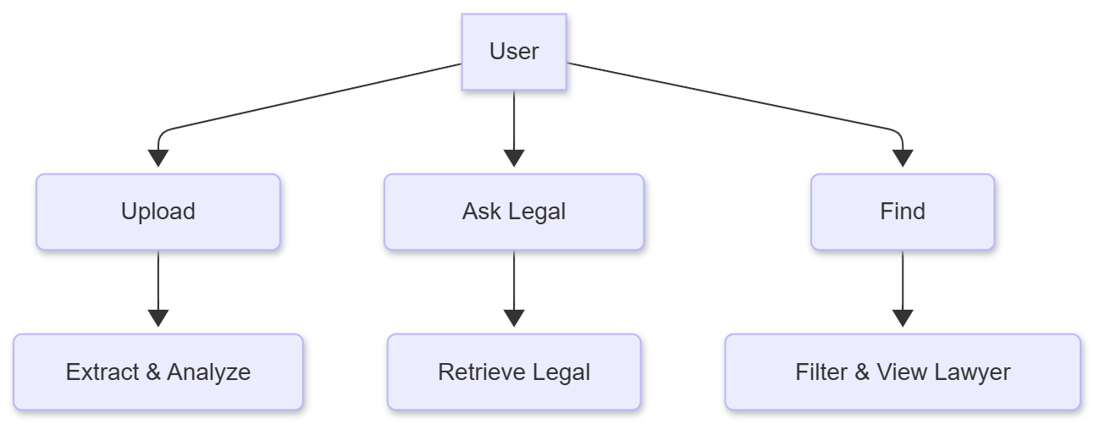

Fig. 4. Use Case Diagram

Data Flow Diagram (Level 0)

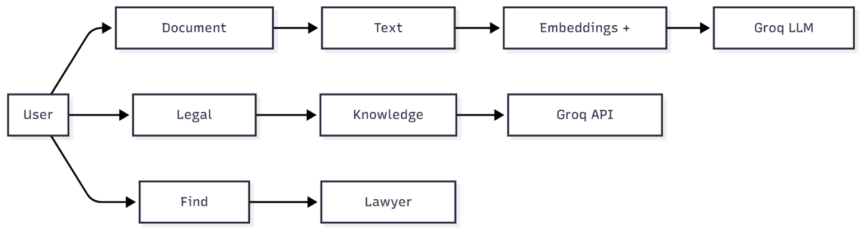

Fig. 5. Data Flow Diagram (Level 0)

Chapter 5

DESIGN & METHODOLOGY

System Architecture Overview:

The overall architecture is based on the Retrieval-Augmented Generation (RAG) approach for legal question answering and a modular design for lawyer search.

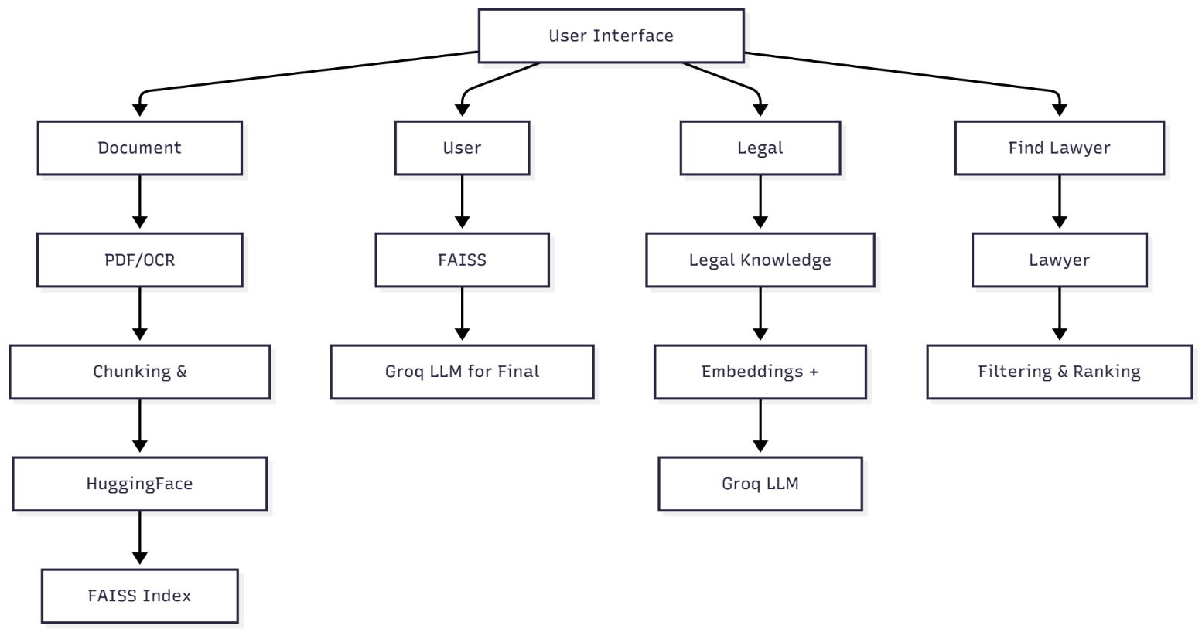

Fig. 6. System Architecture

Methodology Overview:

The system operates through the following structured pipeline:
- Document Processing
- Embedding Generation
- Vector Indexing (FAISS)
- Query Retrieval
- LLM-based Response Generation
- Lawyer Search and Filtering
Each step is explained in detail in the subsections below.

Document Analyzer – Design & Workflow:

The Document Analyzer processes user-uploaded PDFs, extracts text, generates embeddings, and answers document-specific queries.

Workflow Diagram

Fig. 7. Workflow Diagram-1

Techniques Used

1. Text Extraction

PyPDF2 / PDFPlumber for digital PDFs

Tesseract OCR for scanned documents

Ensures maximum text accuracy

2. Preprocessing

Removing unwanted symbols

Normalizing whitespace

Lowercasing (optional)

3. Chunking Algorithm

Documents are divided into chunks of 500–1000 tokens to maintain context without overwhelming embeddings.

Users and Characteristics

Model used: sentence-transformers/all-MiniLM-L6-v2

Output: 384–768 dimension vectors

Stored locally in a FAISS index for fast retrieval

Indexing Using FAISS

Why FAISS?

Extremely fast vector search

Efficient for large documents

Low memory overhead

FAISS stores embeddings & returns top-k relevant chunks for the user query.

Answer Generation (Groq API)

Once FAISS retrieves relevant chunks:

Chunks are passed to the Groq LLM

Model generates a grounded answer

Response includes simplified explanation

Groq ensures high-speed, low-latency reasoning.

Legal Chatbot – Design & Workflow:

Documents are divided into chunks of 500–1000 tokens to maintain context without overwhelming embeddings.

Workflow Diagram

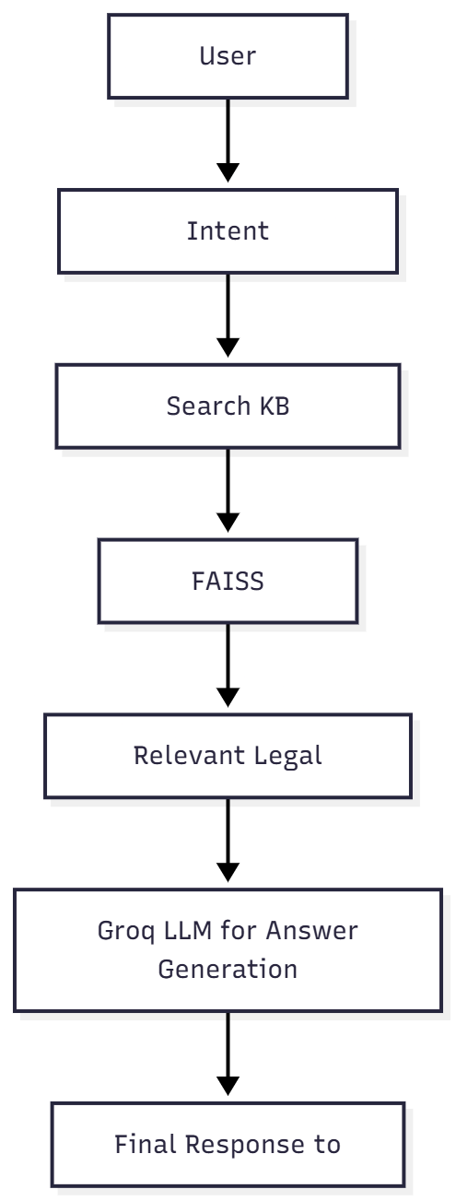

Fig. 8. Workflow Diagram-2

Training Process

Dataset Sources:

Government law sites (manual curation)

Legal blogs & summaries

Court judgement summaries

Training Steps:

Collect curated domain-specific documents

Clean and preprocess legal text

Create embeddings for each legal section

Build FAISS index of the entire knowledge base

Use Groq LLM to generate final answers

Why Domain-Specific?

Reduces hallucination

Ensures accurate referencing

Provides consistent and reliable output

Prevents responses about unrelated laws

Find Lawyer Module – Design & Workflow:

The Find Lawyer module displays, filters, and sorts lawyer profiles.

Workflow Diagram

Fig. 9. Workflow Diagram-2

Dataset Structure

Field | Description
Name | Lawyer full name
Expertise | Marriage Law / Employment Law / Criminal / Civil
Experience | No. of years
Location | City
Rating | Out of 5
Contact | Phone/Email

Table IX Dataset Structure

Filtering Process

Filter by expertise

Filter by rating (>=4)

Filter by experience (>5 years)

Sort by:

highest rating

most experienced

User Interface Design:

Developed using Streamlit

UI Characteristics:

Clean dashboard

Sidebar navigation

Three separate tabs for modules

Real-time LLM feedback

Multilingual support (basic)

- UI Flow Diagram
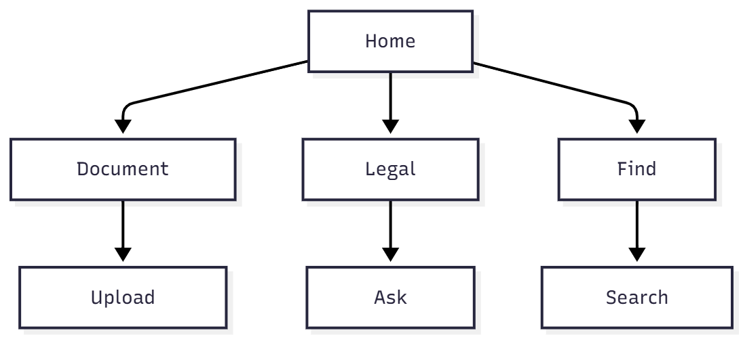

Fig. 10. UI Flow Diagram

System Algorithms:

1. Document Chunking Algorithm

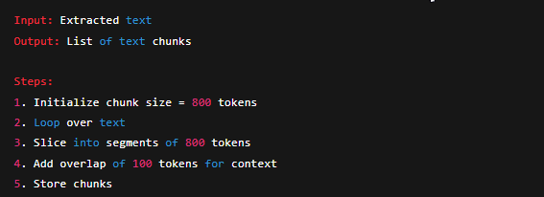

2. FAISS Retrieval Algorithm

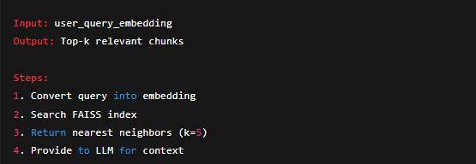

3. Lawyer Filtering Algorithm

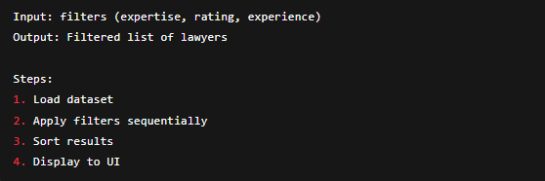

Technology Stack:

Component | Technology Used
Frontend | Streamlit
Backend | Python
AI Model | Groq LLM
Embeddings | HuggingFace
Database (Vectors) | FAISS
OCR | Tesseract
Data Storage | JSON/CSV
Deployment | Render / Cloud

Table X Technology Stack

Chapter 6

CONCLUSION

The AI Legal Assistant System successfully demonstrates how modern AI techniques can simplify legal processes and make legal information more accessible to the general public. By integrating document analysis, domain-specific legal question answering, and a lawyer search module into a single platform, the system reduces the time, effort, and complexity involved in understanding legal documents and basic laws. The use of NLP, HuggingFace embeddings, FAISS retrieval, and Groq LLM ensures high accuracy, fast responses, and grounded answers based on real legal text.

Overall, the system provides a reliable, user-friendly, and scalable solution that addresses the common limitations of traditional chatbots and manual legal research. While the current system focuses on Marriage and Employment Laws, it lays a strong foundation for future expansion into additional legal domains, multilingual support, and enhanced professional features. The project demonstrates the potential of AI-driven tools in transforming legal accessibility and empowering users with informed decision-making.

REFERENCES

[1] J. Miller and S. Thompson, “AI-driven Legal Document Summarization Using NLP Techniques,” IEEE Transactions on Legal Informatics, vol. 18, no. 2, Mar. 2020. [Online]. Available: https://ieeexplore.ieee.org/
[2] A. Deshmukh and K. Patil, “A Retrieval-Augmented Legal Question Answering System,” Springer Journal of Intelligent Information Retrieval, vol. 9, no. 1, Jan. 2021. [Online]. Available: https://link.springer.com/
[3] Y. Chen and D. Roberts, “FAISS-based Semantic Search Optimization for Large-Scale Text Repositories,” Elsevier Journal of Data Engineering, vol. 14, no. 6, Jun. 2020. [Online]. Available: https://www.sciencedirect.com/
[4] P. Sharma and R. Kumar, “Legal Chatbots Using Deep Learning and Knowledge Bases,” IEEE International Conference on Artificial Intelligence and Law (ICAIL), vol. 11, Jul. 2019. [Online]. Available: https://ieeexplore.ieee.org/
[5] M. Rodriguez and E. Clark, “OCR and Text Extraction Techniques for Scanned Legal Documents,” ACM Digital Library on Document Engineering, vol. 22, no. 4, Oct. 2021. [Online]. Available: https://dl.acm.org/
[6] A. Syed and F. Noor, “Improving Legal Decision Support Systems Using Large Language Models,” Elsevier Journal of AI & Society, vol. 15, no. 3, Feb. 2022. [Online]. Available: https://www.sciencedirect.com/
[7] J. Wilson and H. Lee, “AI-Powered Lawyer Recommendation Platforms,” Springer Handbook of Legal Technology, vol. 5, Sep. 2020. [Online]. Available: https://link.springer.com/
[8] R. Verma and S. Nair, “Developing Multilingual Legal Assistance Systems Using NLP,” IEEE Conference on Human-Centric AI, vol. 13, Dec. 2019. [Online]. Available: https://ieeexplore.ieee.org/
[9] D. Harper and O. Martin, “Designing Secure Legal Data Processing Systems,” Elsevier Journal of Information Security, vol. 17, no. 2, Apr. 2021. [Online]. Available: https://www.sciencedirect.com/
[10] Groq Inc., “Groq LLM API Documentation.” [Online]. Available: https://groq.com/
[11] HuggingFace, “Sentence Transformer Models and Documentation.” [Online]. Available: https://huggingface.co/
[12] Facebook AI Research, “FAISS: A Library for Efficient Similarity Search.” [Online]. Available: https://faiss.ai/
[13] Streamlit Inc., “Streamlit Framework Documentation.” [Online]. Available: https://docs.streamlit.io/
[14] Python Software Foundation, “Python Official Documentation.” [Online]. Available: https://www.python.org/doc/

